The Hierarchical System of Criteria Parameters Determination based on Teaching Extracts

Practice of decision making in science, constructional, management fields shows that we have deal with some and usually big number of criteria, which are objectives of system parameters optimization or objectives of management problems estimate. We apply multi-criteria methods when we are to choose achieved by mutual concession solutions, for example to choose between price and quality.
I work with hierarchical system of criteria. This model is useful when the number of criteria is big. The main idea lies in decomposition of universe of discourse in form of tree and after that aggregation of the tree. The model is obvious and is build just the way human think about problem.
I show this system of criteria on example:
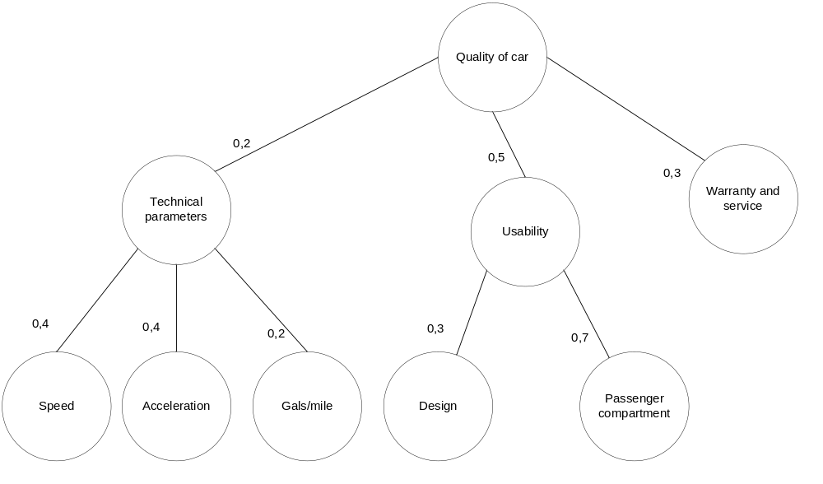

As we can see on the diagram “Quality of car” is depend on three factors: Technical parameters, Usability and Warranty and service, then we decompose these factors until we get single factors that we are able to measure somehow: either in quantitative or in workmanlike manner. To give estimation by this model we should build such tree and provide rules of conversion and aggregation. In the leaves (so called Single Criteria) we use conversion functions that map real values to [0; 1] scale. 1 is the best one and 0 is the worst one:
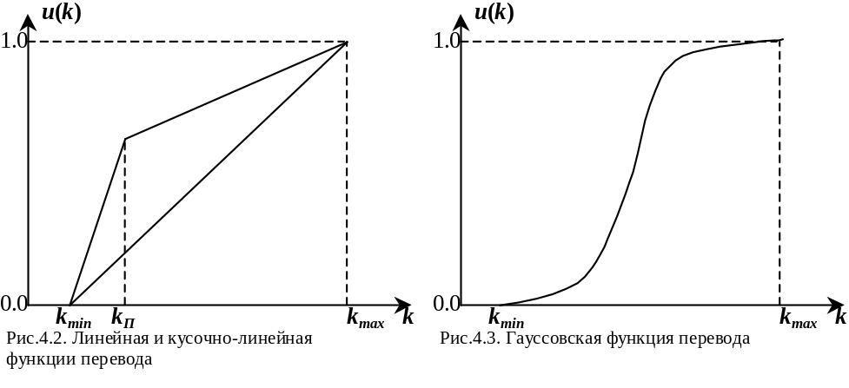
Than in other vertex (so called Complex Criteria) of the tree we apply aggregation operators to aggregate values. In this model we use the operators of the special form.
- 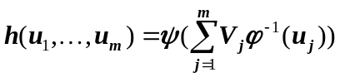, where
h(1,1,…,1)=1;
h(u₁,1,…,1)<1 when u₁<l;
h(u₁,0,…,0)>0 when u₁>0;
h(0,0,…,0)=0.
- 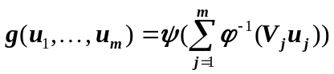
g(1,1,…,1)=1;
g(u₁,1,…,1)<1 when u₁<l;
g(u₁,0,…,0)>0 when u₁>0;
g(0,0,…,0)=0.

These operators have weight V_{j} and their purpose is to give estimation based on these weight. So as in example above where speed and acceleration have more priority over gals/mile than if
In real life we have 3 types of such operators:
- additive
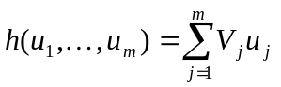
Just weighted additivity.
- quasi-conjunctive
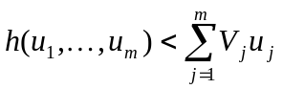
This operator return “good” values only if all inputs are good.
So Technical parameters are good when all Speed, Acceleration and Gals/mile are good.
- quasi-disjunctive
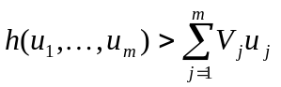
This operator return “good” values if at least one input is good.

And after we’ve formed the tree we can solve multicriterial problems. Output of the root operator (so called Integral criterion) is estimation of the model. More is better.
This model gives good results but a person who works with it must provide correct weights and other parameters to the model (aggregation operator types). And my research is how to select parameters of the tree based on big teaching set of objects.
The purpose of searching values of parameters is close to the purpose of classical regression. We can analyze evaluations produced by the model formed from real data and the model from expert. In this analyze we can find reasons of difference that could be, for example, in underestimation of overestimation some factors.

Optimization algorithm
Input: combination of inputs (single criteria) and output (integral criterion)
Output: operator types, weighs.
The goal of the algorithm is to determine such parameters of the hierarchical system of criteria: operator types, weighs – that’s estimation of the model is better fit than base one that is done by Expert.
Remark: In analyze of the model showed that it’s not unimodal so we can only improve base estimations and cannot guarantee absolute optimization.
The objective function of optimization is least-squares method estimation of function values deviation from real data.
The algorithm is iterated. During the single iteration we go through each complex criteria and starts multidimensional optimization. Variables in that case are type and weights of current operator only. For each criterion we try to find close state that gives better results as they do in method of Hooke-Jeeves and than starts «pattern-matching search» and do only several steps of optimization for current criterion. After that go to the next criterion. After all criteria are done we start next iteration. Process stops when the model gives estimations are close to real data enough.
We use weight-first traversal of the tree and this gives us uniformity of optimization.

We have developed this algorithm and the program tool that helps to work with complex xriteria trees and apply optimization using real data:

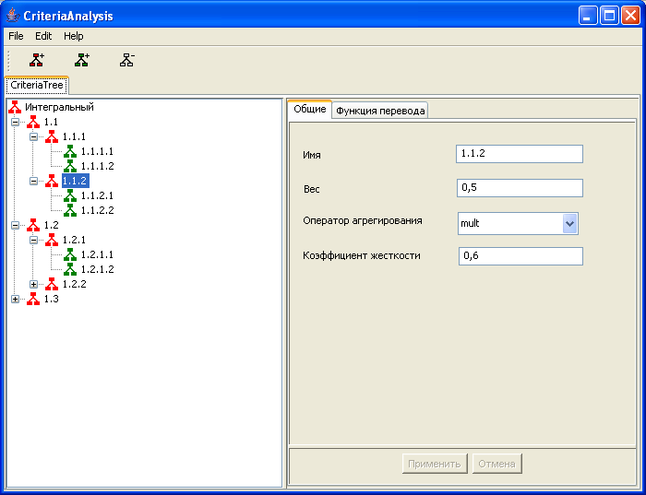

Conclustion

The hierarchical system of criteria model is a good instrument for solving multicriteria problems and applying our algorithm gives the ability to analyze expert model parameters and study factor’s influence.

